Parth Babbar

MORTGAGE LENDING PROCESS, LOAN UNDERWRITTING PROCESS & DEBT COLLECTION PRACTICES
Mortgage Lending Process:
The mortgage financing process in the United States consists of numerous major phases, ranging from pre-qualification to closing. It often includes:
- Pre-qualification: A preliminary examination of a borrower's financial status.
- Pre-approval: A more thorough examination, which frequently includes a credit check.
- House Shopping: The borrower searches for a property within the pre-approved amount.
- Loan Application: A formal request for a mortgage.
- Loan Processing: Verifying financial facts.
- Underwriting: A thorough risk evaluation by the lender.
- Approval and Closing: Final approval, document signature, and fund disbursement.
Pre-qualification:
- Purpose: Determine the maximum loan amount that the applicant can afford.
- Based on: Income, debt, and savings.
- Process:
1.The borrower provides basic financial information.
2.The lender reviews the information given.
3.The lender assesses the maximum loan amount that the borrower can afford.
Pre-approval:
- Purpose: Provide a conditional commitment from the lender.
- Key factors: Credit score and detailed financial analysis.
- Process:
1.Borrowers file a formal application.
2.The lender runs a credit check.
3.The lender reviews extensive financial documents.
House Shopping:
- Purpose: Find a suitable home to purchase.
- Key Factors: Location and Price Range
- Process:
1.Borrowers utilize pre-approval to determine their budget.
2.The borrower looks for houses within their budget.
3.The borrower puts an offer on residences that suit their requirements.
Loan Application:
- Purpose: Submit a formal mortgage application.
- Key Factors: Income Verification & Employment-History
- Process:
1.The borrower fills out a loan application form.
2.The borrower provides supporting documentation for income and employment verification.
Loan-Processing:
- Purpose: Verify the borrower's submitted information.
- Key factors: Bank statements and tax returns.
- Process:
1.Lenders verify borrower employment, income, and financial soundness.
2.The lender obtains a property valuation.
Underwriting:
- Purpose: Risk assessment and loan terms.
- Key factors: Creditworthiness & Property Appraisal
- Process:
1.Underwriters analyse all submitted documents.
2.The underwriter assesses the property's worth.
3.The underwriter determines the borrower's capacity to repay the loan.
Approval and Closing:
- Purpose: Finalizing the mortgage arrangement.
- Key Factors:
1.Document signing.
2.Payment for Closing Costs
- Process:
1.The lender grants final permission for the mortgage.
2.The borrower and seller sign the closing paperwork.
3.The funds are disbursed to conclude the transaction.
Challenges:
- Affordability: Rising housing prices and mortgage rates make owning less affordable.
- Credit Access: Since the 2008 financial crisis, lenders have tightened lending rules, making it more difficult for some consumers to qualify.
- Complexity: The mortgage procedure is long and requires a large amount of paperwork, which may be intimidating for consumers.
Solutions:
- Affordability: First-time homebuyer programs, VA loans, FHA loans, and other government initiatives can all contribute to the affordability of housing.
- Credit Access: Developing alternative credit scoring models that take into account non-traditional data sources, such as rental payments and utility bills, can assist to increase credit availability.
- Complexity: By using digital platforms to expedite the application process, automate document collecting, and offer clear communication, you may minimize complexity and improve the borrower experience.
Statistics:
- Average Mortgage Rate: As of 2023, the average mortgage rate in the United States was around 6.5%.
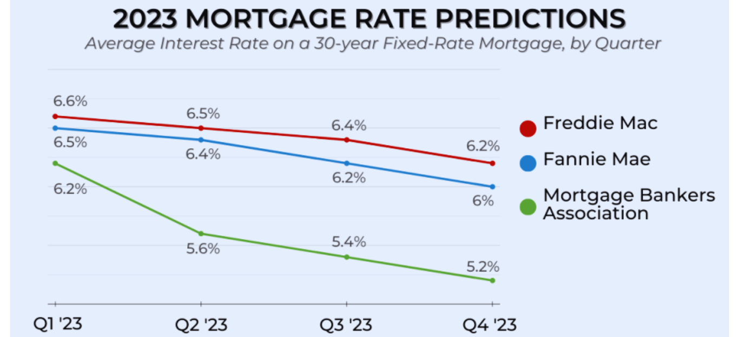
- Homeownership Rate: About 65.8% of Americans own a home.
- Average Mortgage Debt: The average mortgage debt per borrower is around $208,185.
- Mortgage Origination Volume: In 2022, the overall mortgage origination volume was around $4.4 trillion.
- Default Rate: The mortgage default rate was around 2.2% in 2023.
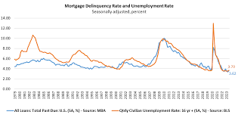
Conclusion:
The mortgage financing process in the United States is multidimensional, with phases ranging from initial pre-qualification to final closure. It necessitates rigorous financial analysis, precise paperwork, and a comprehensive appraisal by lenders. Despite its difficulties, the procedure is critical for facilitating homeownership, promoting economic stability, and allowing individuals to invest in property. As the housing market advances, using technology and regulatory changes may simplify procedures and increase accessibility, making homeownership more accessible to a wider range of borrowers.
Loan Underwriting Process:
Loan underwriting is the process by which lenders determine the risk of providing money. It entails a thorough examination of the borrower's financial information to establish the loan's terms and conditions.
Application Review:
- Purpose: Evaluate borrower's initial mortgage application.
- Key Factors: Income, Employment, and Credit History.
- Process: The lender does a first screening of the application to ensure that all necessary information is given.
Credit Analysis:
- Purpose: Determine borrower's creditworthiness.
- Key factors: Credit score and credit report.
- Process:
1.The lender undertakes a thorough analysis of the borrower's credit history.
2.This includes reviewing your payment history, existing obligations, and recent credit queries.
Capacity Assessment:
- Purpose: Evaluate borrower repayment capacity.
- Key factors: Debt-to-income ratio and income stability.
- Process:
1.The lender looks at the borrower's income and spending.
2.To analyse financial commitments, calculate the debt-to-income ratio.
3.An assessment of income stability to establish the borrower's capacity to repay the loan.
Collateral Evaluation:
- Purpose: Determine the value of the collateral.
- Key factors: Property appraisal and asset valuation.
- Process:
1.An independent evaluation is performed on the property or assets presented as security.
2.The evaluation assesses the collateral's current market worth.
Circumstances Review:
- Purpose: Evaluate loan terms in relation to market circumstances.
- Key Factors: Interest Rates and Loan Purpose.
- Process:
1. Examine the present market circumstances and interest rate patterns.
2.Consider the loan's precise purpose.
3.Using the study of these elements, choose the best acceptable loan conditions.
Final Decision:
- Purpose: To approve or refuse the loan.
- Key Factors: Overall risk assessment.
- Process: After a thorough analysis of all aspects, the underwriter makes a final decision to accept or refuse the loan and determines the terms and conditions if authorized.
Challenges:
- Accuracy: Providing accurate and full information throughout the underwriting process is vital yet difficult.
- Prejudice: Credit scoring methods may contain prejudice, which can disproportionately harm particular groups.
- Efficiency: The underwriting procedure can be time-consuming and resource-intensive, causing loan approval delays.
Solutions:
- Accuracy: You may improve accuracy and lower mistakes by utilizing third-party data sources and automating data verification processes.
- Bias: Creating and implementing inclusive and transparent credit scoring models that include a broader variety of data inputs can assist to reduce bias.
- Effectiveness: Using AI and machine learning technology can speed up the underwriting process by automating repetitive processes and giving more accurate risk evaluations.
Statistics:
- Average Approval Rate: Between 60 and 70% of mortgage applications are accepted.
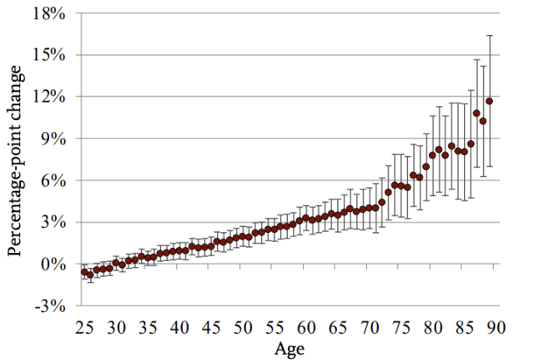
- Average Credit Score: Approved mortgage applicants have an average credit score of around 720.
- Underwriting Time: Loan underwriting typically takes 30 to 45 days.
- Loan Default Rate: The loan default rate for mortgages is around 2-3%.
- Usage of Automated Underwriting Systems (AUS): AUS is used by more than 90% of mortgage lenders to expedite the underwriting process.
Conclusion:
The US loan underwriting procedure is critical in determining mortgage loan viability and conditions. To minimize lender losses, it thoroughly analyses financial data, examines creditworthiness, and assesses risks. Efficient underwriting not only encourages ethical lending, but also speeds up loan approvals, increasing borrower satisfaction. Leveraging automated technology and inclusive credit scoring models can help to expedite processes while maintaining transparency and fairness. Adapting to regulatory changes and market developments is critical for ensuring the process's integrity and efficiency.
Debt Collection Practices:
Debt collection is the process of seeking repayment for debts owed by people or corporations. It is a heavily regulated procedure, with rules like the Fair Debt Collection Practices Act (FDCPA) controlling behaviour.
Initial Contact:
- Purpose: Inform the debtor about the outstanding debt.
- Key factors: Debt verification and communication methods.
- Process:
1.Debt collectors contact debtors by phone, mail, or email.
2.Inform the debtor of the existence of the debt.
3.Provide information for proving the debt upon request.
Negotiation:
- Purpose: Establish repayment conditions.
- Key Factors: Payment Plans and Settlements
- Process: Debt collectors work with the debtor to create a realistic repayment plan or settlement agreement.
Monitoring:
- Purpose: Monitor payments to verify agreement compliance.
- Key factors: Payment history and ongoing communication.
- Process:
1.Regularly monitor the debtor's payments.
2.Maintain communication to verify that the payback schedule is followed as agreed.
Legal Action:
- Purpose: Legally enforce repayment as required.
- Key Factors: Court Decisions & Wage garnishments
- Process:
1.If the debtor does not comply with the repayment arrangement, the debt collector may take legal action.
2. Obtain a court order to compel collection.
3.Use wage garnishments or other legally allowed methods to ensure payments.
Challenges:
- Compliance: Following regulatory standards such as the FDCPA and state regulations is crucial and can be difficult.
- Consumer Protection: Striking a balance between collection operations and consumer rights to prevent harassment and assure fair treatment.
- Reputation: Maintaining a favourable image while engaged in debt collecting efforts might be challenging owing to negative opinions.
Solutions:
- Compliance: Train debt collectors on legal requirements and best practices, and conduct regular audits to guarantee conformity to legislation.
- Consumer Protection: Transparent and fair collection processes, accurate information for debtors, and flexible repayment choices.
- Reputation: Implementing ethical collecting tactics, investing in customer service training, and utilizing technology to increase communication and facilitate dispute resolution.
Statistics:
- Size of the Debt Collection business: In 2023, the US debt collection business was estimated to be worth around $20.9 billion.
- Consumer Debt: The total consumer debt in the United States surpasses $17.3 trillion
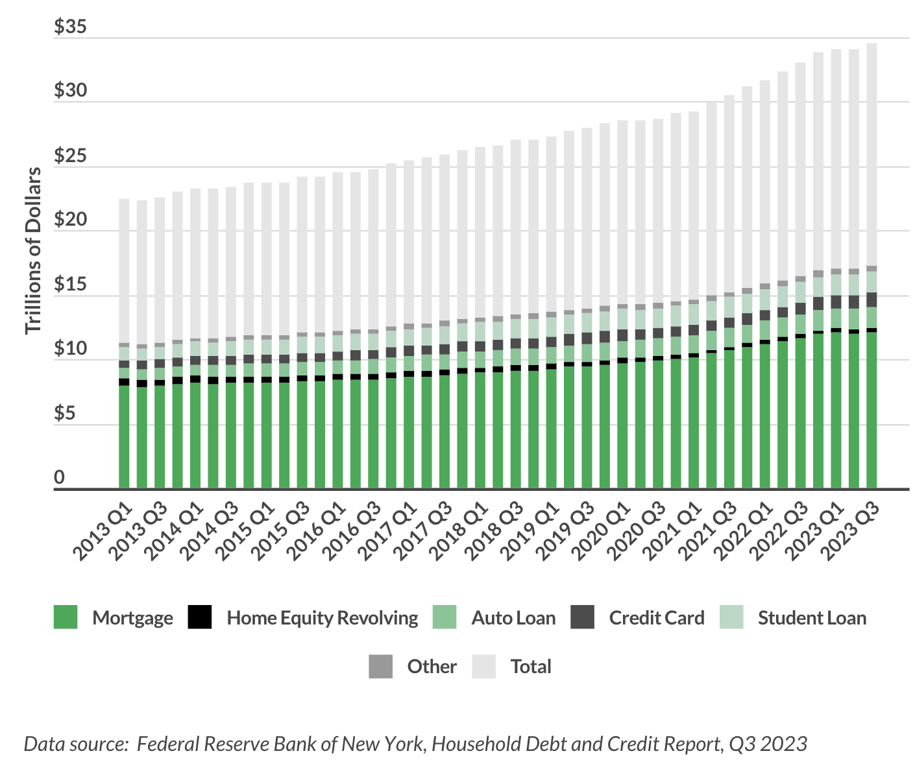.
- Collection Success Rate: The typical success rate for debt collection is between 20 and 30%.
- Complaints: The Consumer Financial Protection Bureau (CFPB) received more than 85,000 complaints concerning debt collection methods in 2022.
- Regulation Impact: Stricter restrictions have resulted in fewer aggressive collecting strategies and more compliance-focused operations.
Conclusion:
Debt collection in the United States is critical for recovering debts while negotiating rigorous legal frameworks designed to protect consumer rights. Clear communication, fair agreements on payback conditions, and compliance with regulations such as the FDCPA are all examples of effective methods. Balancing creditor interests and consumer protection is critical to sustaining industry confidence. As approaches advance, ethical norms, digital transparency tools, and consumer-centric solutions become increasingly important for long-term debt recovery. Following standards and communicating proactively with debtors are critical for ethical and effective debt collection.

